Day 5:

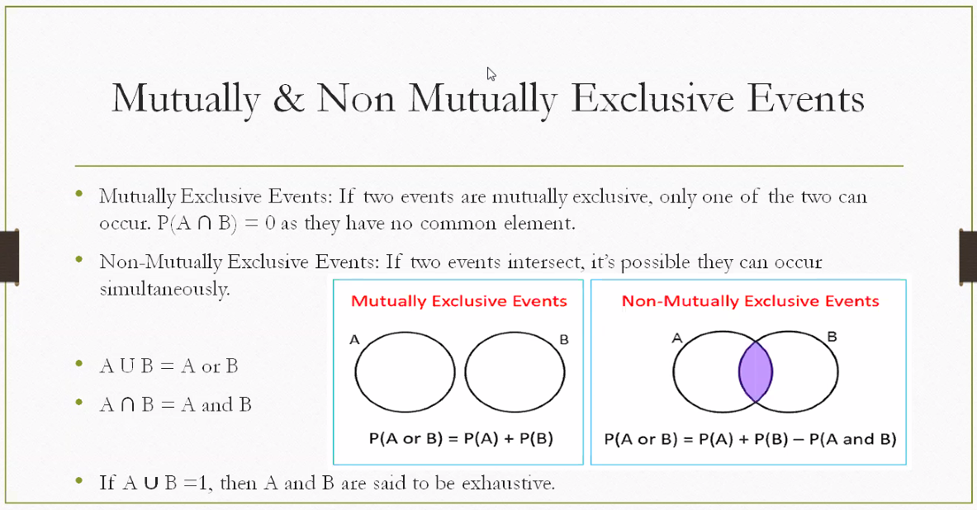

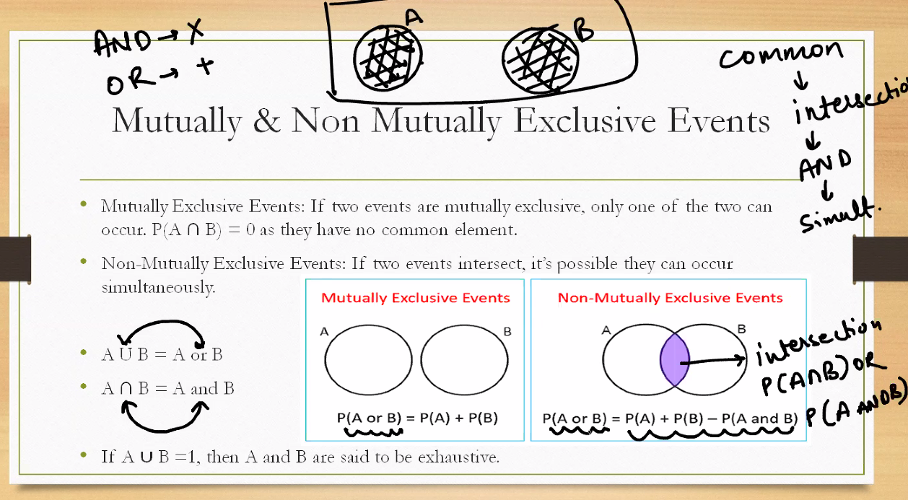

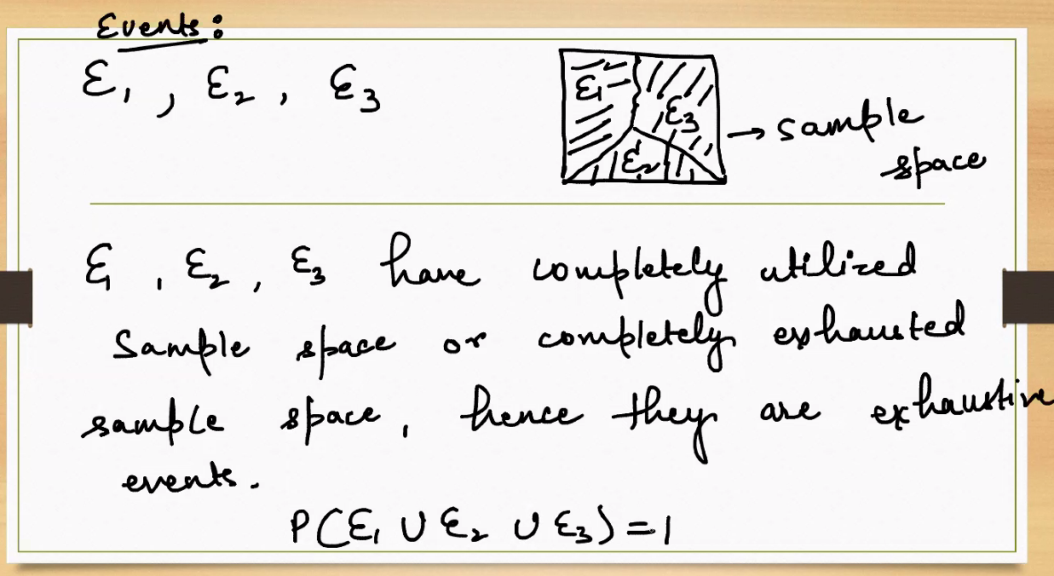

**🎯 What Are Exhaustive Events?**

**Definition:** A set of events is called *exhaustive* if **at least one of them must occur** when an experiment is performed. In other words, they **collectively cover the entire sample space**.

**📦 Sample Space and Events**

* **Sample Space (S):** The set of all possible outcomes of a random experiment.
* **Events (E₁, E₂, E₃):** Subsets of the sample space.

If

$$P(E_{1}∪E_{2}∪E_{3})=1$$

then $E_{1},E_{2},E_{3}$ are exhaustive because their union equals the entire sample space.

**✅ Key Properties**

* **Coverage: $E_{1}∪E_{2}∪E_{3}=S$**
* **Probability Sum: $P(E_{1}∪E_{2}∪E_{3})=1$**
* **Not necessarily mutually exclusive:** Events can overlap unless specified.

**📌 Real-Life Example**

**Rolling a die:**

* Let $E_{1}=\{1,2\}$, $E_{2}=\{3,4\}$, $E_{3}=\{5,6\}$
* These events are exhaustive because together they cover all outcomes: {1, 2, 3, 4, 5, 6}

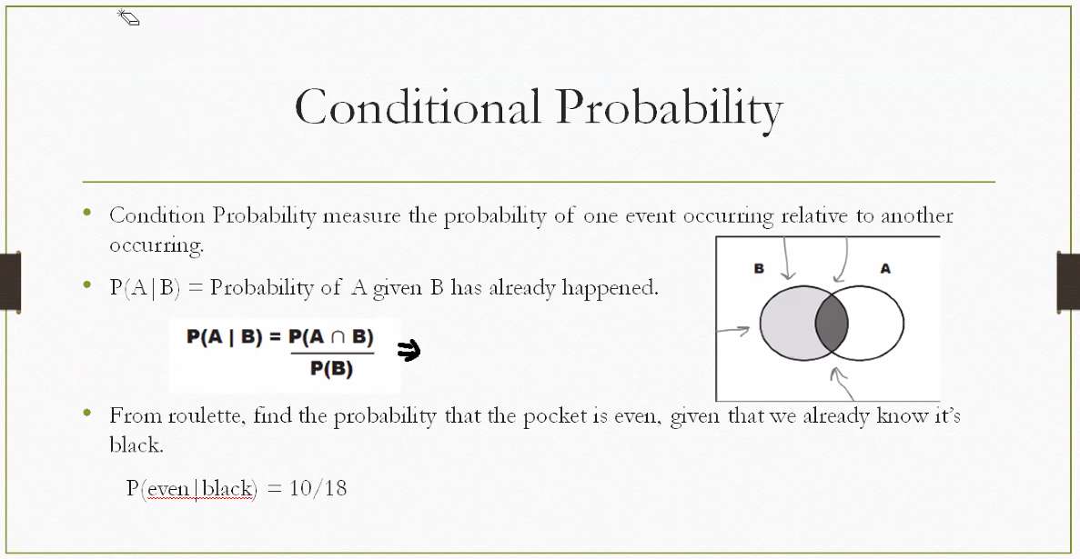

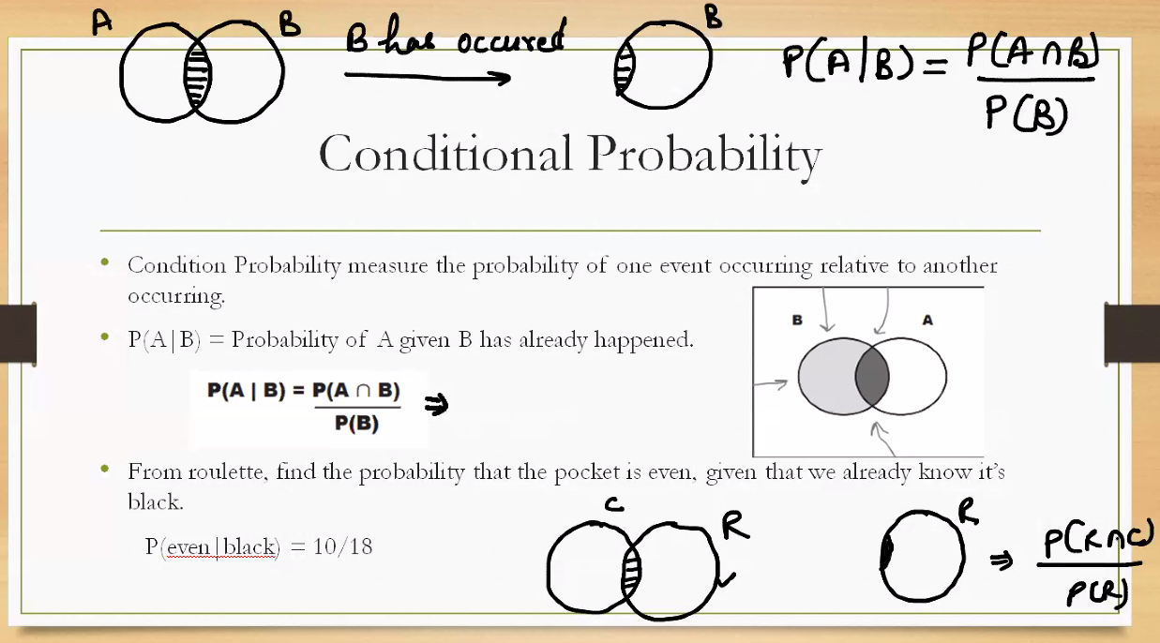

**🎯 What Is Conditional Probability?**

**Definition:** Conditional probability measures the likelihood of an event **given that another event has already occurred**.

**Formula:**

$$P(A∣B)=\frac{P(A∩B)}{P(B)}$$

This reads as: *“The probability of A happening given B has occurred”*.

**📌 Worked Example from the Slide**

**Problem:** "Find the probability that the pocket is even, given that we already know it is red."

**Solution:**

$$P(\text{Even}∣\text{Red})=\frac{10}{18}$$

This means: Out of 18 red pockets, 10 are even — so the conditional probability is $\frac{10}{18}$.

**✅ Key Takeaways**

* Conditional probability **narrows the sample space** to only the known condition.
* It’s foundational for **Bayes’ Theorem**, **decision trees**, and **machine learning**.
* Always check that $P(B)≠0$— you can't condition on an impossible event.

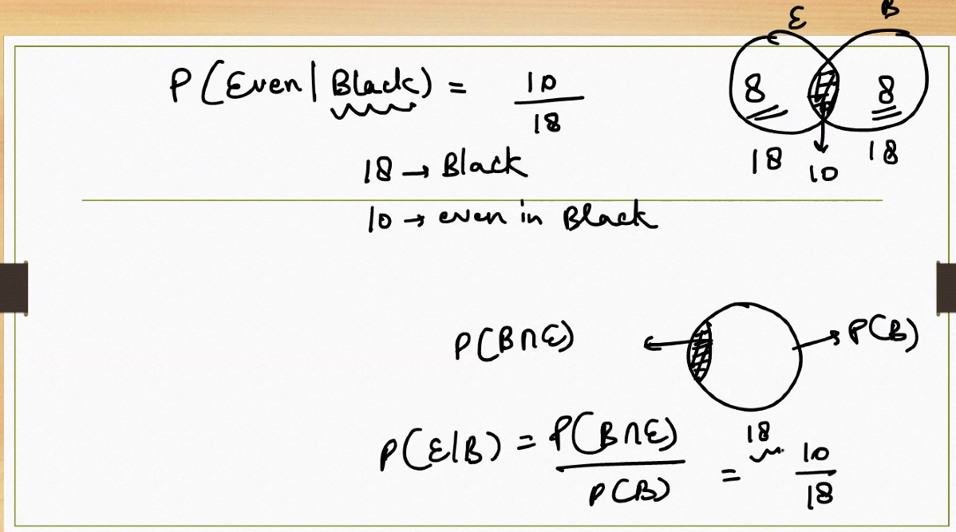

**🎯 Concept: Conditional Probability Recap**

**Formula:**

$$P(E∣B)=\frac{P(E∩B)}{P(B)}$$

This reads as: *“Probability of event E occurring given that event B has occurred.”*

**📊 Visual Breakdown from the Venn Diagram**

* **Circle E (Even numbers):** Contains 8 elements
* **Circle B (Black pockets):** Contains 18 elements
* **Intersection $E∩B$:** Contains 10 elements (even and black)

So:

$P(E∩B)=\frac{10}{36}$

$P(B)=\frac{18}{36}$

**✅ Final Calculation**

Using the formula:

$$P(E∣B)=\frac{P(E∩B)}{P(B)}=\frac{10/36}{18/36}=\frac{10}{18}$$

This means: **Given that the pocket is black, the probability that it is even is $\frac{10}{18}$.**

**🧠 Interpretation**

You're **narrowing the sample space** to only black pockets (18 total), and asking: *Among those, how many are even?* Answer: 10 out of 18 → $\frac{10}{18}$

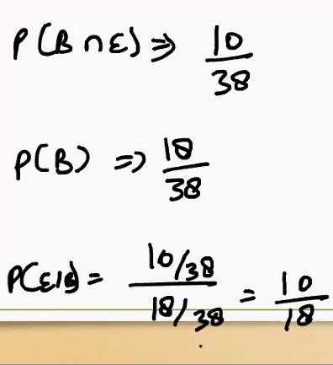

**🎯 Concept Recap: Conditional Probability**

The formula is:

$$P(E∣B)=\frac{P(E∩B)}{P(B)}$$

This calculates the probability of event **E** occurring **given** that event **B** has already occurred.

**📊 Breakdown of the Example**

From your notes:

* $P(B∩E)=\frac{10}{38}$: Probability that both events (Black and Even) occur.
* $P(B)=\frac{18}{38}$: Probability that the event Black occurs.
* Applying the formula:

$$P(E∣B)=\frac{10/38}{18/38}=\frac{10}{18}$$

**✅ Interpretation**

This means: **Given that the outcome is Black**, the probability that it is also Even is $\frac{10}{18}$.

You're **restricting the sample space** to only Black outcomes (18 total), and asking: *Among those, how many are Even?* Answer: 10 out of 18 → $\frac{10}{18}$

**🧠 Why This Matters**

Conditional probability is foundational for:

* **Bayes’ Theorem**
* **Decision-making under uncertainty**
* **Machine learning models**
* **Risk analysis and diagnostics**

In the formulas:

$P(B∩E)=\frac{10}{38}$

$P(B)=\frac{18}{38}$

This implies:

* There are **38 total items** (e.g., balls, pockets, cards — depending on the scenario).
* Out of those, **18 are Black**, and **10 are both Black and Even**.

So, 38 is the **total number of possible outcomes** you're considering for this probability experiment.

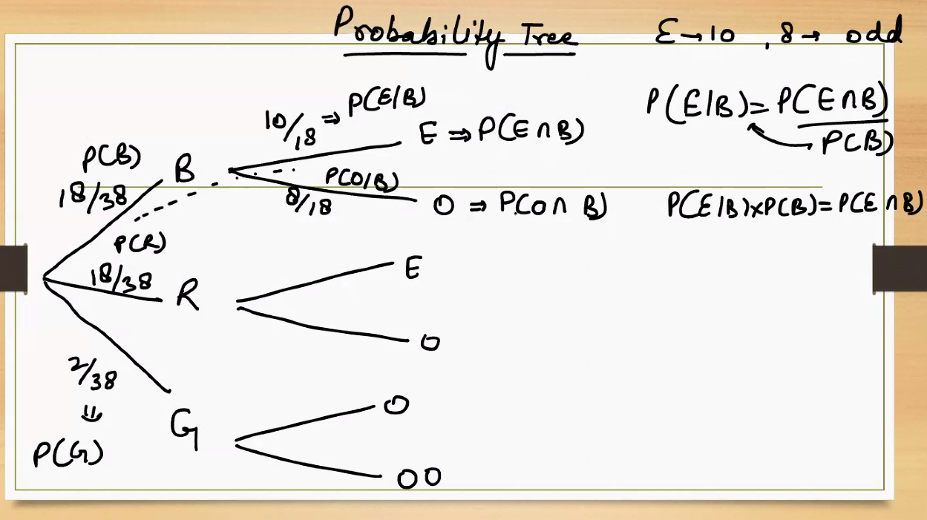

**🌳 What Is a Probability Tree?**

A **probability tree** is a diagram that helps visualize sequences of events and their associated probabilities. Each branch represents a possible outcome, and you multiply along the branches to calculate joint probabilities.

**🧩 Structure of Your Tree**

**1. First Split:**

* **B (Black)** → Probability: $\frac{18}{38}$
* **G (Green)** → Probability: $\frac{2}{38}$

This means: Out of 38 total outcomes, 18 are Black and 2 are Green.

**2. Second Split from B:**

* **E (Even) → $P(E∣B)=\frac{10}{18}$**
* **O (Odd) → $P(O∣B)=\frac{8}{18}$**

This shows conditional probabilities: Given that the outcome is Black, 10 are Even and 8 are Odd.

**3. Joint Probabilities:**

To find the probability of both events happening (e.g., Even and Black), multiply along the path:

$P(E∩B)=P(E∣B)⋅P(B)=\frac{10}{18}⋅\frac{18}{38}=\frac{10}{38}$

$P(O∩B)=\frac{8}{18}⋅\frac{18}{38}=\frac{8}{38}$

**✅ Key Formulas Used**

* **Conditional Probability:**
$$P(E∣B)=\frac{P(E∩B)}{P(B)}$$

* **Joint Probability (from tree):**

$$P(E∩B)=P(E∣B)⋅P(B)$$

**🧠 Why This Matters**

This tree helps you:

* Visualize how conditional probabilities work.
* Understand how to compute joint probabilities.
* See how the sample space narrows as you condition on earlier events.

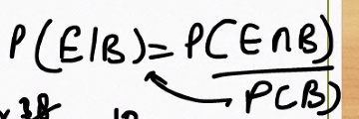

**🎯 The Formula**

$$P(E∣B)=\frac{P(E∩B)}{P(B)}$$

This reads as: **“The probability of event E occurring, given that event B has occurred.”**

**🧠 What It Means**

* $P(E∣B)$: Conditional probability — how likely E is *within the context of B*.
* $P(E∩B)$: Joint probability — how likely both E and B happen together.
* $P(B)$: Probability that B happens — your new reference frame.

You're **zooming in** on the part of the sample space where B has already occurred, and asking: *Within that subset, how likely is E?*

**📊 Example**

Suppose:

* You have 38 balls.
* 18 are Black.
* 10 are both Black and Even.

Then:

$P(B)=\frac{18}{38}$

$P(E∩B)=\frac{10}{38}$

So:

$$P(E∣B)=\frac{10/38}{18/38}=\frac{10}{18}$$

This means: **Given that a ball is Black, the chance it's Even is $\frac{10}{18}$.**

**🔁 Rearranged Form**

You can also flip the formula to find joint probability:

$$P(E∩B)=P(E∣B)⋅P(B)$$

This is useful in probability trees and Bayesian reasoning.

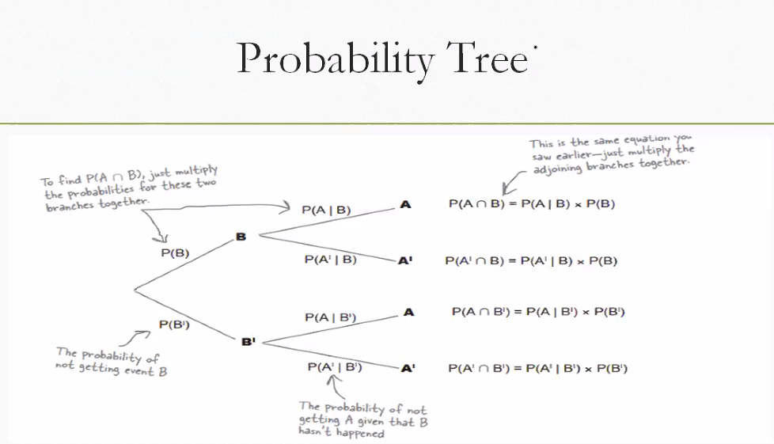

**🌳 What Is a Probability Tree?**

A **probability tree** helps you map out sequences of events and calculate the probability of combined outcomes. Each branch represents a decision point or event, and you multiply probabilities along the branches to get joint probabilities.

**🧩 Structure of Your Tree**

**1. First Split: Event B**

* **B** → Probability $P(B)$
* **B′ (not B)** → Probability $P(B\text{'})=1-P(B)$

This is the first event — say, whether a ball is Black or not.

**2. Second Split: Event A**

From each branch (B and B′), you split again:

* From **B**:
  + **A** → $P(A∣B)$
  + **A′** → $P(A\text{'}∣B)$
* From **B′**:
  + **A** → $P(A∣B\text{'})$
  + **A′** → $P(A\text{'}∣B\text{'})$

These are conditional probabilities — how likely A or A′ is, given B or B′.

**🧮 How to Compute Joint Probabilities**

You multiply along the branches:

$P(A∩B)=P(A∣B)⋅P(B)$

$P(A∩B\text{'})=P(A∣B\text{'})⋅P(B\text{'})$

$P(A\text{'}∩B)=P(A\text{'}∣B)⋅P(B)$

$P(A\text{'}∩B\text{'})=P(A\text{'}∣B\text{'})⋅P(B\text{'})$

Each of these gives you the probability of two events happening together.

**✅ Why This Is Useful**

* It helps you **organize complex probability problems**.
* You can **visualize dependencies** between events.
* It’s essential for **Bayesian reasoning**, **decision trees**, and **risk modeling**.

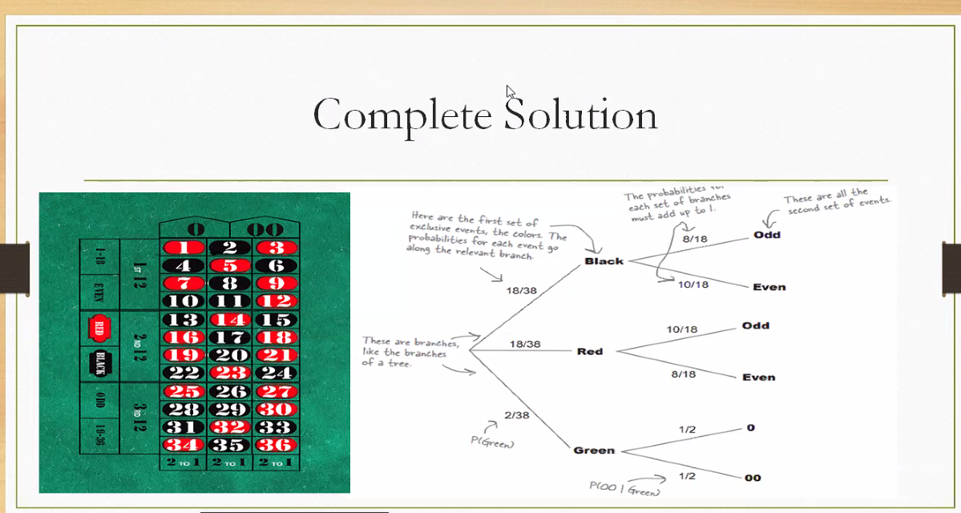

**🎰 Part 1: The Roulette Setup**

* A standard roulette wheel has **38 slots**:
  + **18 Red**
  + **18 Black**
  + **2 Green** (0 and 00)

Each slot is equally likely, so:

$P(\text{Red})=\frac{18}{38}$

$P(\text{Black})=\frac{18}{38}$

$P(\text{Green})=\frac{2}{38}$

**🌳 Part 2: The Probability Tree**

This tree visualizes **two-stage outcomes**:

1. **Color** (Black, Red, Green)
2. **Parity** (Odd or Even)

**🖤 Black Branch:**

$P(\text{Black})=\frac{18}{38}$

* Given Black:

$P(\text{Odd}∣\text{Black})=\frac{8}{18}$

$P(\text{Even}∣\text{Black})=\frac{10}{18}$

**❤️ Red Branch:**

$P(\text{Red})=\frac{18}{38}$

* Given Red:

$P(\text{Odd}∣\text{Red})=\frac{10}{18}$

$P(\text{Even}∣\text{Red})=\frac{8}{18}$

**💚 Green Branch:**

$P(\text{Green})=\frac{2}{38}$

* Given Green:

$P(\text{Odd}∣\text{Green})=\frac{0}{2}$

$P(\text{Even}∣\text{Green})=\frac{2}{2}$

**🧮 How to Use the Tree**

To find **joint probabilities**, multiply along the branches:

$P(\text{Black}∩\text{Even})=\frac{18}{38}⋅\frac{10}{18}=\frac{10}{38}$

$P(\text{Red}∩\text{Odd})=\frac{18}{38}⋅\frac{10}{18}=\frac{10}{38}$

$P(\text{Green}∩\text{Even})=\frac{2}{38}⋅\frac{2}{2}=\frac{2}{38}$

This lets you calculate the probability of compound events like “Even and Red” or “Odd and Black.”

**✅ Why This Is Powerful**

* It shows **conditional probabilities** clearly.
* It helps compute **joint probabilities**.
* It’s a great tool for **decision-making**, **game theory**, and **Bayesian reasoning**.

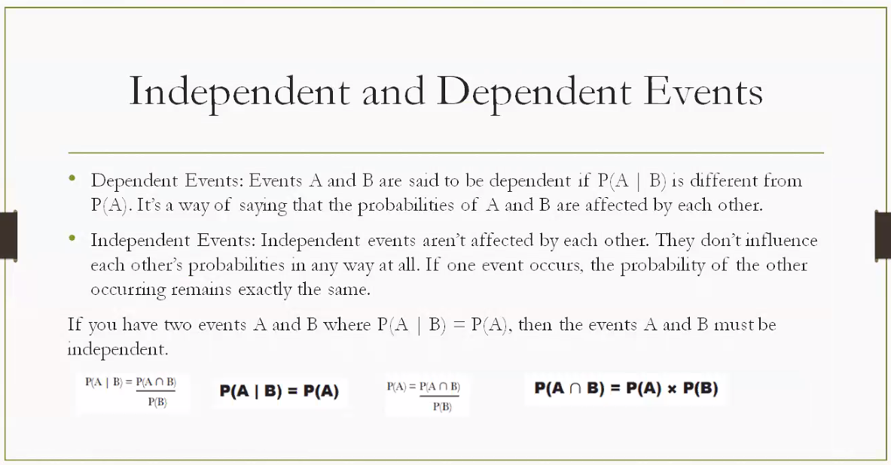

**🛍️ Dependent Events Example: Buying a Laptop and Getting a Discount**

**Scenario:**

* **Event A:** You buy a laptop during a festive sale.
* **Event B:** You receive a 20% discount.

**Why Dependent?**

The likelihood of getting a discount **depends on** whether you're buying during a sale. So:

$$P(B∣A)≠P(B)$$

**🎬 Independent Events Example: Watching a Movie and Getting a Job Offer**

**Scenario:**

* **Event A:** You watch a movie tonight.
* **Event B:** You receive a job offer tomorrow.

**Why Independent?**

Your movie choice has no bearing on whether a recruiter sends you an offer. These events occur in separate domains.

$$P(B∣A)=P(B)$$

When events are independent then,



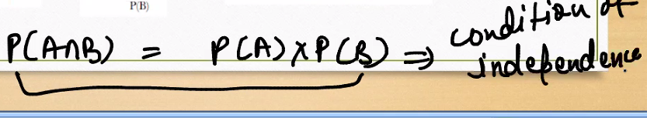

**🧠 The Equation**

$$P(A∩B)=P(A)⋅P(B)$$

This means: **The probability that both events A and B happen together is equal to the product of their individual probabilities.**

**✅ What It Implies**

This equation holds **if and only if** A and B are **independent events**.

* **Independent events**: The occurrence of one does **not affect** the probability of the other.
* If this condition is true, then:

$$P(A∣B)=P(A)\text{and}P(B∣A)=P(B)$$

**📊 Example: Rolling Two Dice**

* **Event A**: First die shows a 4 → $P(A)=\frac{1}{6}$
* **Event B**: Second die shows a 2 → $P(B)=\frac{1}{6}$
* Since the dice are independent:

$$P(A∩B)=\frac{1}{6}⋅\frac{1}{6}=\frac{1}{36}$$

**⚠️ If Events Are Dependent**

Then:

$$P(A∩B)≠P(A)⋅P(B)$$

Instead, you’d use:

$$P(A∩B)=P(A∣B)⋅P(B)$$

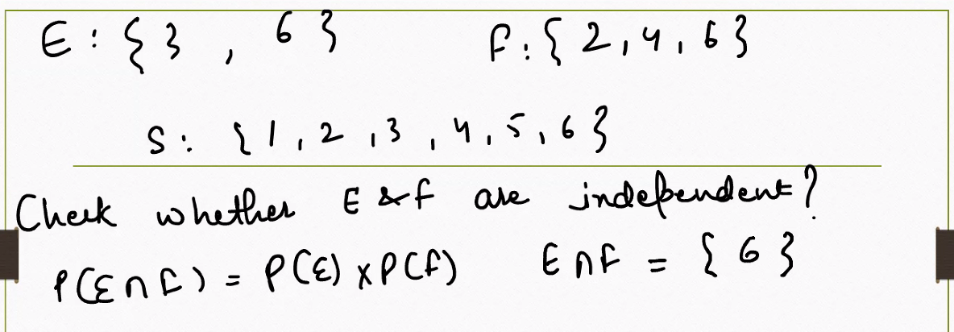

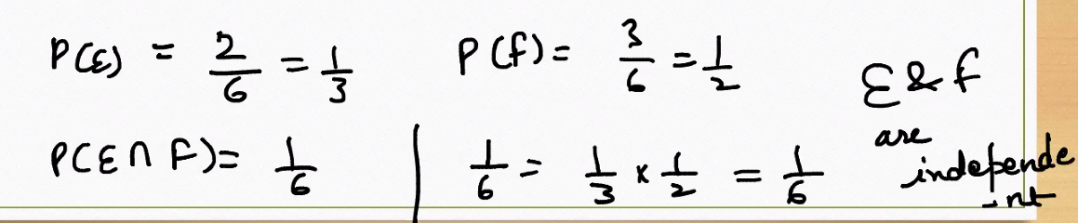

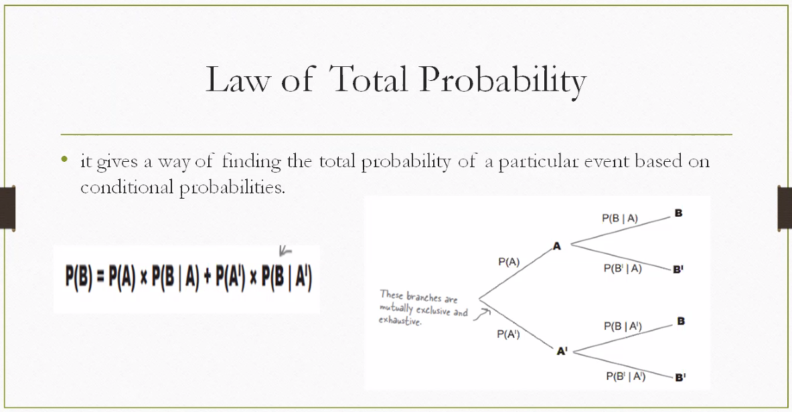

**📘 Law of Total Probability: The Formula**

$$P(B)=P(A)⋅P(B∣A)+P(A^{'})⋅P(B∣A^{'})$$

This means: To find the total probability of event **B**, you consider:

* The probability that **A** happens and then **B** happens given **A**
* Plus the probability that **A′** (not A) happens and then **B** happens given **A′**

**🌳 Tree Diagram Intuition**

The tree splits into:

* **A** and **A′** (mutually exclusive and exhaustive)
* From each, you branch into **B** and **B′**

You multiply along each path and then **add** the paths that end in **B**.

**🎯 Real-Life Example: Email Spam Detection**

Let’s say:

* **A**: Email is from an unknown sender → $P(A)=0.3$
* **A′**: Email is from a known sender → $P(A\text{'})=0.7$

Now:

$P(\text{Spam}∣A)=0.8$

$P(\text{Spam}∣A\text{'})=0.1$

Then:

$$P(\text{Spam})=0.3⋅0.8+0.7⋅0.1=0.24+0.07=0.31$$

So the total probability that an email is spam is **31%**, considering both sender types.

**✅ Why It’s Useful**

* Helps in **Bayesian reasoning**
* Used in **risk modeling**, **diagnostics**, and **machine learning**
* Breaks complex problems into **manageable conditional pieces**

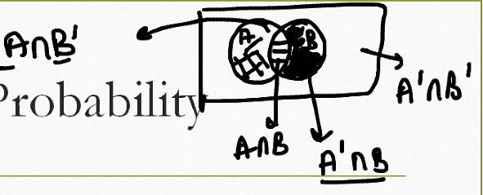

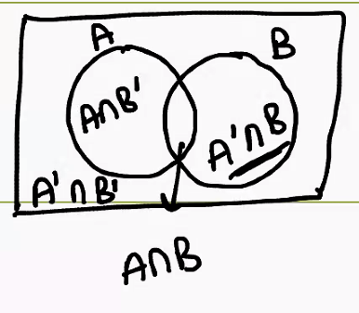

**🎯 Key Notation**

* **A** and **B**: Two events or sets in a sample space.
* **A ∩ B**: The intersection — outcomes common to both A and B.
* **A ∩ B′**: Outcomes in A but **not** in B.
* **A′ ∩ B**: Outcomes in B but **not** in A.

**📊 Visual Interpretation**

Imagine the sample space as a rectangle, and A and B as overlapping circles:

| **Region** | **Meaning** | **Description** |
| --- | --- | --- |
| **A ∩ B** | Both A and B occur | The shaded overlapping area |
| **A ∩ B′** | A occurs, B does not | Left part of A outside B |
| **A′ ∩ B** | B occurs, A does not | Right part of B outside A |

**🧠 Probability Perspective**

Each region corresponds to a **specific subset of outcomes**:

* If you're calculating probabilities, you’d assign values to each region based on how likely those outcomes are.
* These regions are **mutually exclusive** — no overlap between them.
* Together, they help you **partition the sample space** for more precise analysis.

**✅ Real-Life Example**

**Event A**: A student studies math. **Event B**: The student studies science.

* **A ∩ B**: Studies both math and science.
* **A ∩ B′**: Studies math but not science.
* **A′ ∩ B**: Studies science but not math.

This helps you analyze combinations of behaviors or outcomes.

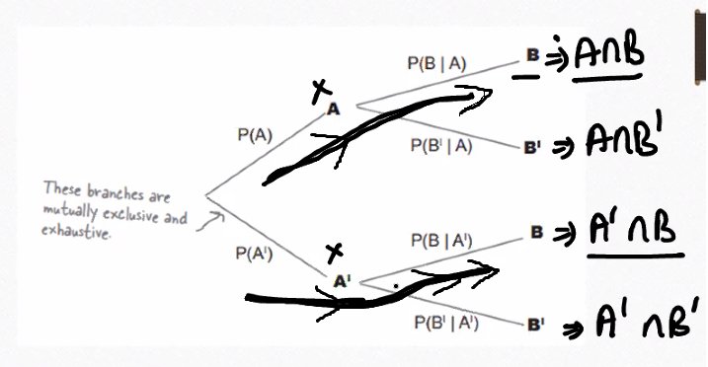

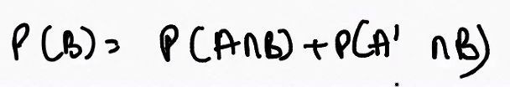



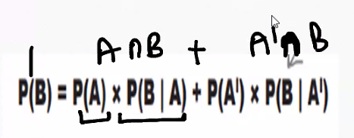

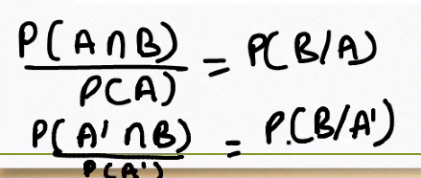

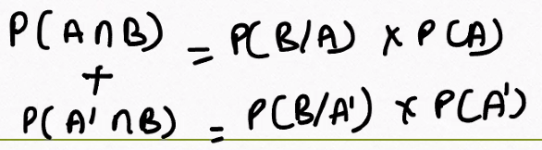

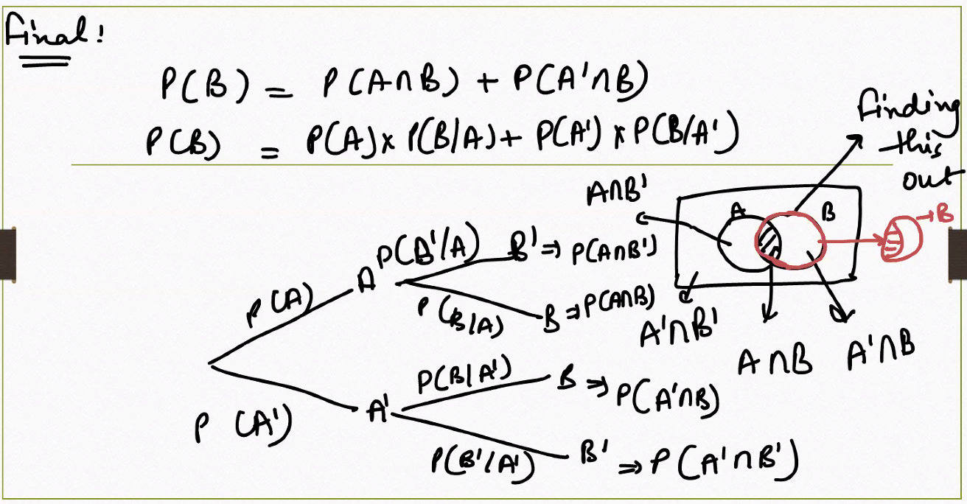

**📘 Key Formula: Law of Total Probability**

$$P(B)=P(A∩B)+P(A^{'}∩B)$$

Or equivalently:

$$P(B)=P(A)⋅P(B∣A)+P(A^{'})⋅P(B∣A^{'})$$

This tells us: To find the total probability of event **B**, you consider **all the ways B can happen** — whether A happens or not.

**🌳 Tree Diagram Breakdown**

The tree shows two stages:

**Stage 1: A or A′**

* $P(A)$: Probability that A happens
* $P(A^{'})$: Probability that A does not happen

**Stage 2: B or B′ given A or A′**

* From A:
  + $P(B∣A)$: Probability of B given A
  + $P(B^{'}∣A)$: Probability of not B given A
* From A′:
  + $P(B∣A^{'})$: Probability of B given A′
  + $P(B^{'}∣A^{'})$: Probability of not B given A′

Each path gives a **joint probability**:

$P(A∩B)=P(A)⋅P(B∣A)$

$P(A^{'}∩B)=P(A^{'})⋅P(B∣A^{'})$

Add them to get total $P(B)$.

**🔵 Venn Diagram Insight**

The Venn diagram shows:

* **A ∩ B**: Both A and B occur
* **A′ ∩ B**: B occurs without A

These are the **two disjoint regions** that together make up all of B:

$$P(B)=P(A∩B)+P(A^{'}∩B)$$

**🧠 Real-Life Analogy**

**Scenario**: Diagnosing a disease

* **A**: Patient has risk factor
* **A′**: Patient does not have risk factor
* **B**: Patient tests positive

Then:

$$P(\text{Positive})=P(\text{Risk})⋅P(\text{Positive}∣\text{Risk})+P(\text{No Risk})⋅P(\text{Positive}∣\text{No Risk})$$

This helps doctors estimate how likely a positive test is across the whole population.

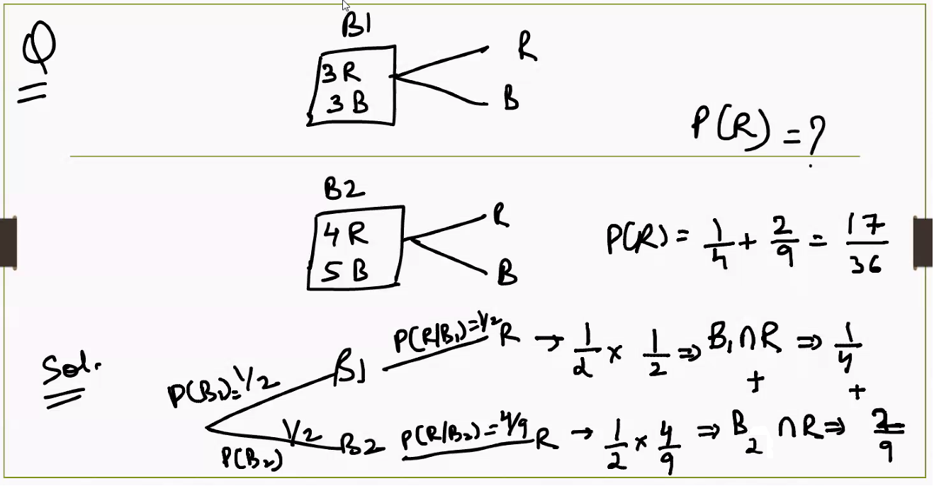

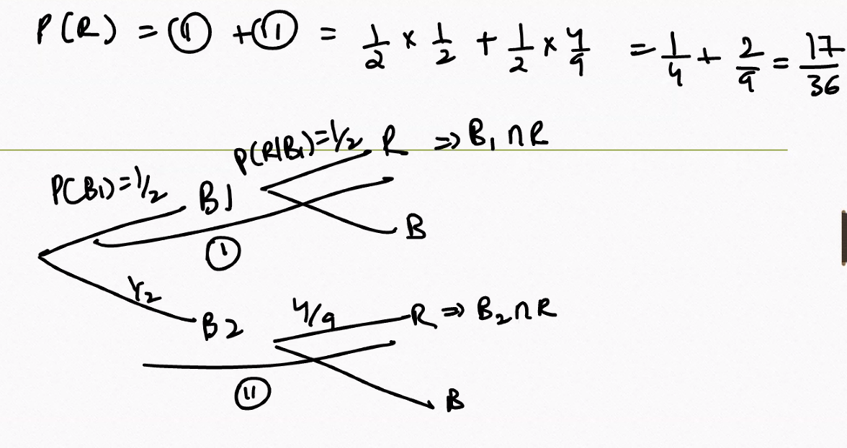

Question :

**Problem Statement:**

* The probability of a strike occurring is **0.65**.
* If there is **no strike**, the probability that the job will be done on time is **0.80**.
* If there **is a strike**, the probability that the job will be done on time is **0.32**.

**📘 Given:**

$P(\text{Strike})=0.65$

$P(\text{No Strike})=1-0.65=0.35$

$P(\text{Job on time}∣\text{Strike})=0.32$

$P(\text{Job on time}∣\text{No Strike})=0.80$

**✅ Correct Formula: Law of Total Probability**

$$P(\text{Job on time})=P(\text{Strike})⋅P(\text{Job on time}∣\text{Strike})+P(\text{No Strike})⋅P(\text{Job on time}∣\text{No Strike})$$

Substitute values:

$$P(\text{Job on time})=0.65⋅0.32+0.35⋅0.80$$

**🧮 Calculation**

$0.65⋅0.32=0.208$

$0.35⋅0.80=0.280$

Add them:

$$P(\text{Job on time})=0.208+0.280=\boxed{0.488}$$

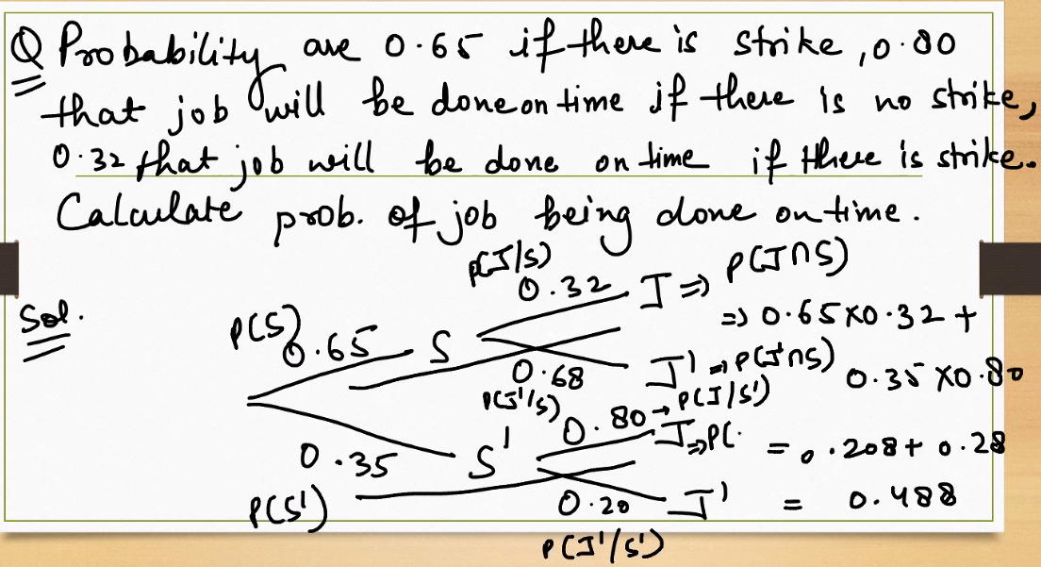

**Question : Give me a porbability job not done on time, along with explaination.**

**📘 Given:**

$P(\text{Strike})=0.65$

$P(\text{No Strike})=0.35$

* $P(\text{Job Done}∣\text{Strike})=0.32$ → so $P(\text{Not Done}∣\text{Strike})=1-0.32=0.68$
* $P(\text{Job Done}∣\text{No Strike})=0.80$ → so $P(\text{Not Done}∣\text{No Strike})=1-0.80=0.20$

**✅ Apply the Law of Total Probability**

$$P(\text{Job Not Done})=P(\text{Strike})⋅P(\text{Not Done}∣\text{Strike})+P(\text{No Strike})⋅P(\text{Not Done}∣\text{No Strike})$$

Substitute values:

$$P(\text{Job Not Done})=0.65⋅0.68+0.35⋅0.20$$

**🧮 Calculation**

$0.65⋅0.68=0.442$

$0.35⋅0.20=0.070$

Add them:

$$P(\text{Job Not Done})=0.442+0.070=\boxed{0.512}$$

**🧠 Interpretation**

There’s a **51.2% chance** the job will **not** be completed on time, factoring in both strike and no-strike scenarios.

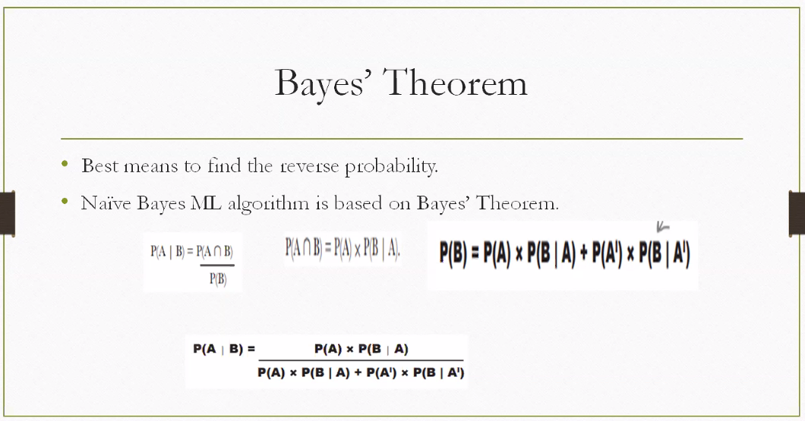

**📘 What Is Bayes’ Theorem?**

Bayes’ Theorem helps you **reverse conditional probabilities** — it tells you how likely a cause (A) is, given an observed effect (B).

**🔢 Core Formula**

$$P(A∣B)=\frac{P(B∣A)⋅P(A)}{P(B)}$$

* $P(A∣B)$: Posterior — probability of A given B (what we want to find)
* $P(B∣A)$: Likelihood — probability of B if A is true
* $P(A)$: Prior — initial belief about A
* $P(B)$: Evidence — total probability of B

**🔄 Reverse Probability**

Bayes’ Theorem is often used to **reverse conditional probabilities**. For example:

* You know how likely a symptom is given a disease.
* You want to know how likely the disease is given the symptom.

**🧠 Supporting Concepts**

**1. Joint Probability**

$$P(A∩B)=P(A)⋅P(B∣A)$$

**2. Law of Total Probability**

$$P(B)=P(A)⋅P(B∣A)+P(A^{'})⋅P(B∣A^{'})$$

**3. Expanded Bayes’ Theorem**

$$P(A∣B)=\frac{P(A)⋅P(B∣A)}{P(A)⋅P(B∣A)+P(A^{'})⋅P(B∣A^{'})}$$

This version is useful when you have two mutually exclusive causes (A and A′).

**🎯 Real-World Example: Medical Diagnosis**

* **A**: Patient has disease
* **A′**: Patient does not have disease
* **B**: Test result is positive

Given:

* $P(A)=0.01$ (1% of population has disease)
* $P(B∣A)=0.95$ (95% test sensitivity)
* $P(B∣A\text{'})=0.05$ (5% false positive rate)

Then:

$$P(A∣B)=\frac{0.01⋅0.95}{0.01⋅0.95+0.99⋅0.05}=\frac{0.0095}{0.0095+0.0495}=\frac{0.0095}{0.059}≈0.161$$

So even with a positive test, the chance the patient actually has the disease is **only ~16.1%**.

**🤖 Naïve Bayes in Machine Learning**

* **Naïve Bayes** assumes all features are **independent** given the class label.
* It uses Bayes’ Theorem to compute:
$$P(\text{Class}∣\text{Features})∝P(\text{Class})⋅∏P({\text{Feature}}_{i}∣\text{Class})$$

* Commonly used in **spam detection**, **sentiment analysis**, and **document classification**.

Deriving the Baye’s theorm :

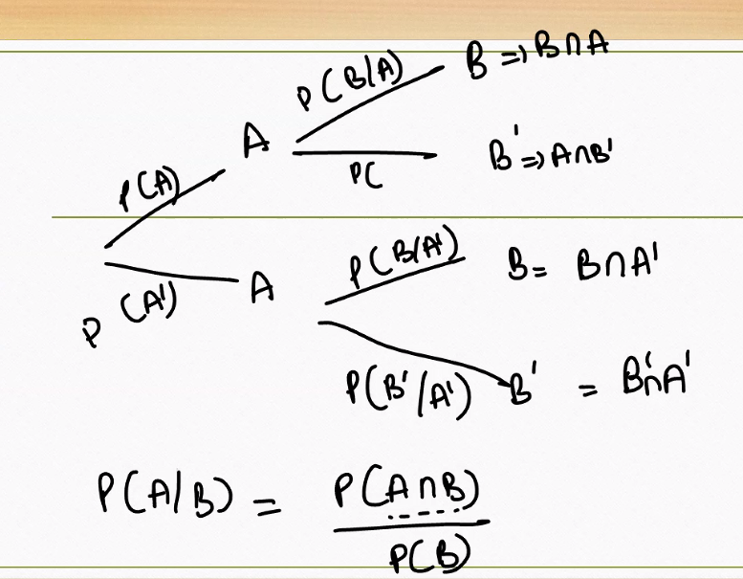

**🔑 Key Concepts in the Image**

**1. Conditional Probability**

$$P(C∣A)$$

This means: the probability of event **C** occurring **given** that event **A** has occurred.

**2. Intersection-Based Conditioning**

$$P(C∣B∩A)$$

This is more specific: the probability of **C** given that **both B and A** have occurred.

**🧩 Set Relationships**

* $B⇒B∩A$: This implies we're narrowing B down to the part that overlaps with A.
* $B^{'}⇒A∩B^{'}$: We're looking at the part of A that does **not** overlap with B.

These help us define **subsets** of the sample space for conditional analysis.

**📘 Bayes’ Theorem Reminder**

$$P(A∣B)=\frac{P(A∩B)}{P(B)}$$

This is the classic definition of conditional probability — the probability of A given B is the ratio of the joint probability to the marginal probability of B.

**🧠 Real-Life Analogy**

Let’s say:

* **A**: A person is a smoker
* **B**: The person has a cough
* **C**: The person has lung disease

Then:

* $P(C∣A)$: Probability of lung disease given smoking
* $P(C∣B∩A)$: Probability of lung disease given both smoking and coughing
* $P(A∣B)$: Probability of being a smoker given that the person has a cough

These help doctors assess risk based on observed symptoms and behaviors.

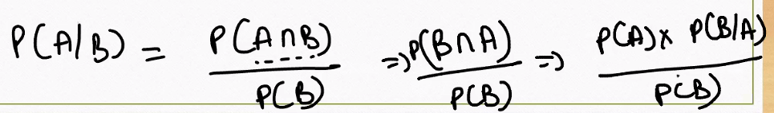

**🔢 Starting Point: Definition of Conditional Probability**

$$P(A∣B)=\frac{P(A∩B)}{P(B)}$$

This means: **The probability of A happening given B has occurred** is the ratio of the probability that both A and B happen, to the probability that B happens.

**🔗 Next Step: Express Joint Probability**

$$P(A∩B)=P(A)⋅P(B∣A)$$

This is the definition of **joint probability** using the **chain rule** — the probability that A happens and then B happens given A.

**🔁 Final Step: Plug into the First Equation**

Substitute into the conditional formula:

$$P(A∣B)=\frac{P(A)⋅P(B∣A)}{P(B)}$$

This is **Bayes’ Theorem** — it lets you **reverse** the direction of conditional probability.

**🧠 Real-Life Example: Email Spam Detection**

* **A**: Email is spam
* **B**: Email contains the word “free”

You know:

$P(\text{Spam})=0.2$

$P(\text{“Free”}∣\text{Spam})=0.7$

$P(\text{“Free”})=0.3$

Then:

$$P(\text{Spam}∣\text{“Free”})=\frac{0.2⋅0.7}{0.3}=\frac{0.14}{0.3}≈0.467$$

So if an email contains “free,” there’s a **46.7% chance** it’s spam.

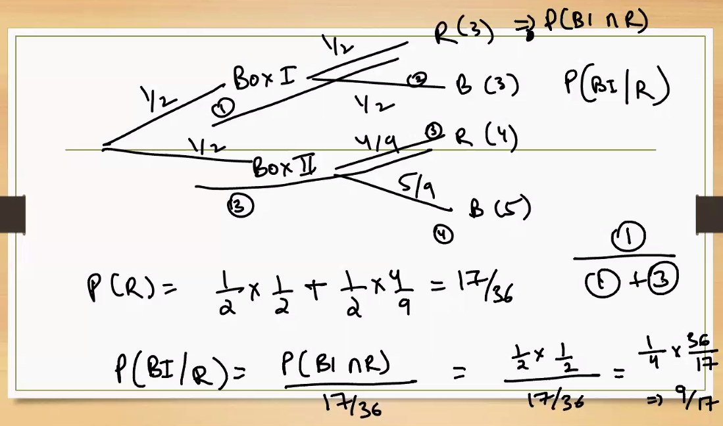

**🎯 Problem Setup**

There are **two boxes**, each with different probabilities of selecting balls:

**📦 Box I**

* Probability of choosing Box I: $P(BI)=\frac{1}{2}$
* From Box I:
  + Probability of selecting a red ball (R): $P(R∣BI)=\frac{1}{2}$

**📦 Box II**

* Probability of choosing Box II: $P(BII)=\frac{1}{2}$
* From Box II:
  + Probability of selecting a red ball: $P(R∣BII)=\frac{4}{9}$

**🧮 Step 1: Total Probability of Drawing a Red Ball**

Using the **Law of Total Probability**:

$$P(R)=P(BI)⋅P(R∣BI)+P(BII)⋅P(R∣BII)$$

Substitute values:

$$P(R)=\frac{1}{2}⋅\frac{1}{2}+\frac{1}{2}⋅\frac{4}{9}=\frac{1}{4}+\frac{2}{9}=\frac{9}{36}+\frac{8}{36}=\frac{17}{36}$$

So, the probability of drawing a red ball is $\frac{17}{36}$.

**🔁 Step 2: Reverse Probability — Bayes’ Theorem**

Now we want to find:

$$P(BI∣R)=\frac{P(BI∩R)}{P(R)}$$

We already know:

$P(BI∩R)=\frac{1}{2}⋅\frac{1}{2}=\frac{1}{4}$

$P(R)=\frac{17}{36}$

So:

$$P(BI∣R)=\frac{\frac{1}{4}}{\frac{17}{36}}=\frac{9}{17}$$

**✅ Final Interpretation**

* **Probability of drawing a red ball**: $\frac{17}{36}$
* **Probability that the red ball came from Box I**: $\frac{9}{17}$

This is a textbook application of **Bayes’ Theorem** — reversing the probability to find the source of an observed outcome.

----------- Practice Example ------------------

